ACI Assignment 1

Course:Artificial and Computational Intelligence

PEAS Environment for the problem:
<Copy of the same contents present in python notebook is added here>

Performance Measure:
Minimized communication lines with un-interrupted network.

Environment:
Shared and distributed servers placed at various locations in the city. Communication lines that connects all these servers.

Actuators (O/P):
The agent's actions responsible for displaying optimum path between servers by activating or deactivating communication lines.

Sensors (I/P):
Sensors in this environment provide information about the current network topology at given instance, also the start and goal node of the distributed server.

Screenshot of the Output:

- Setting Initial state (Getting start & goal node from user)
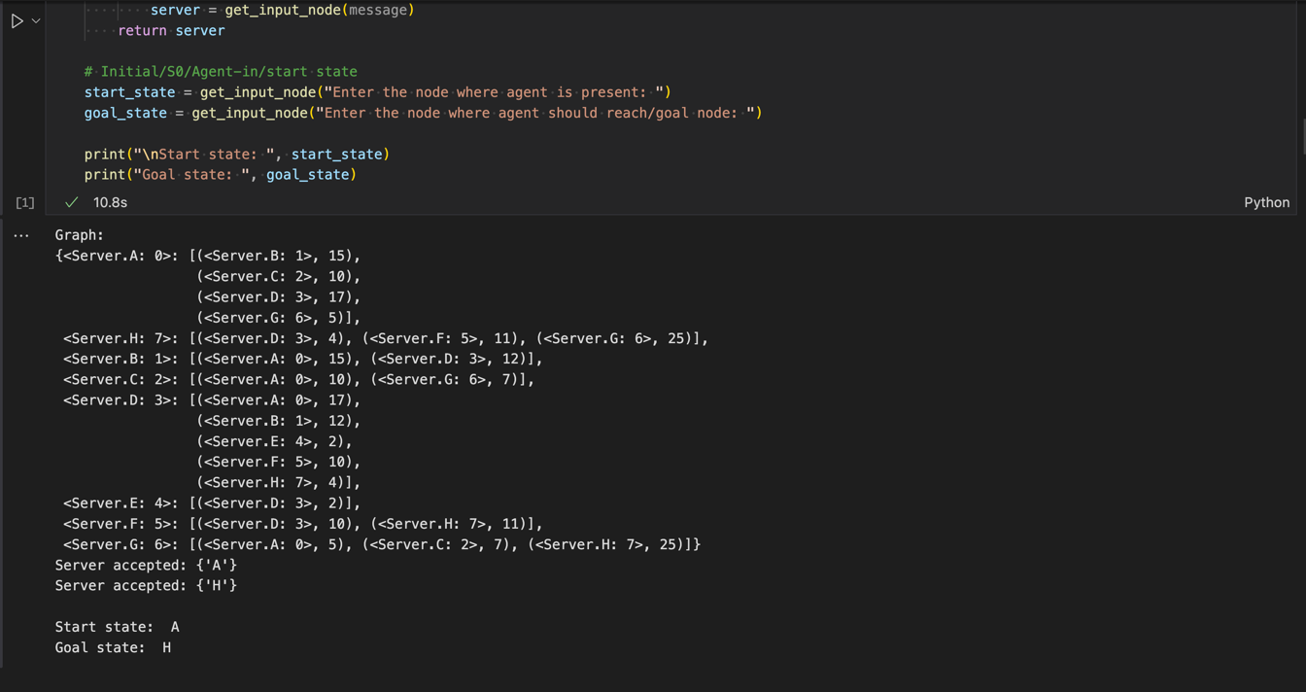

- Setting Transition Cost Matrix:
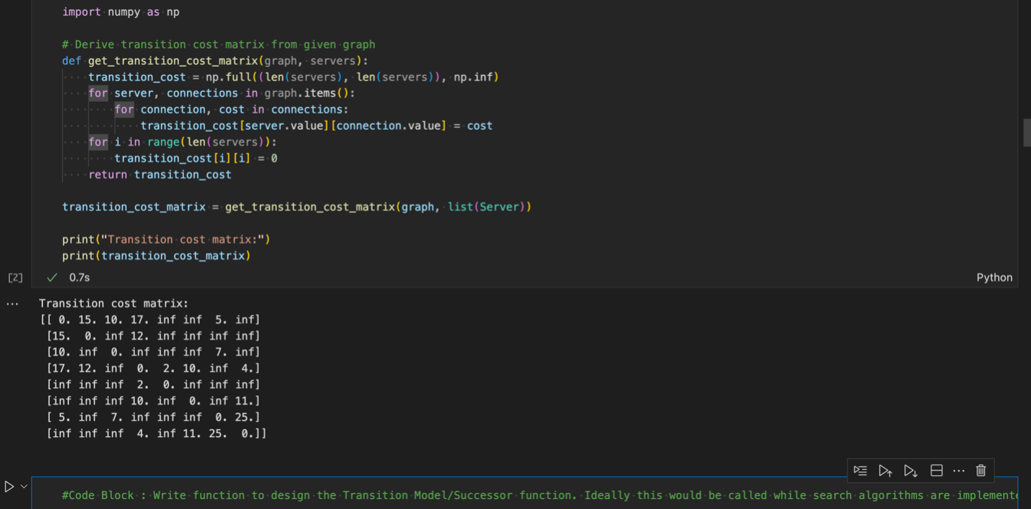

- Heuristic Calculation:
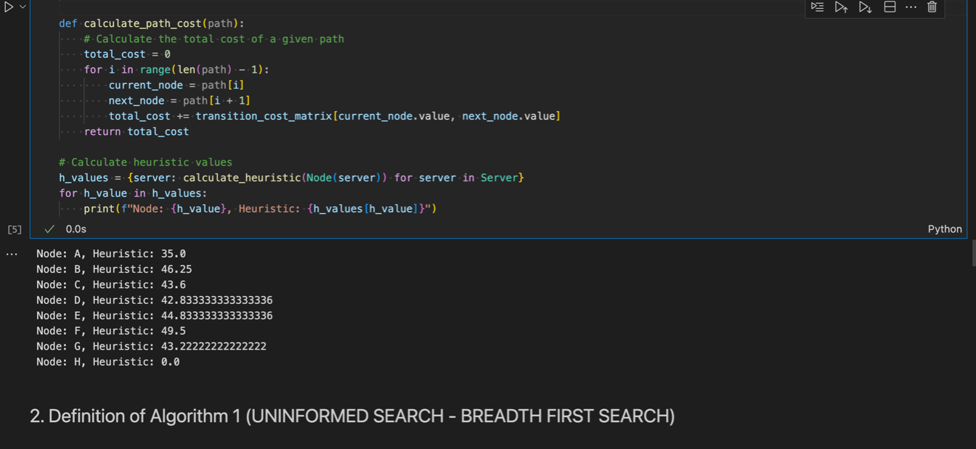

- BFS Result:
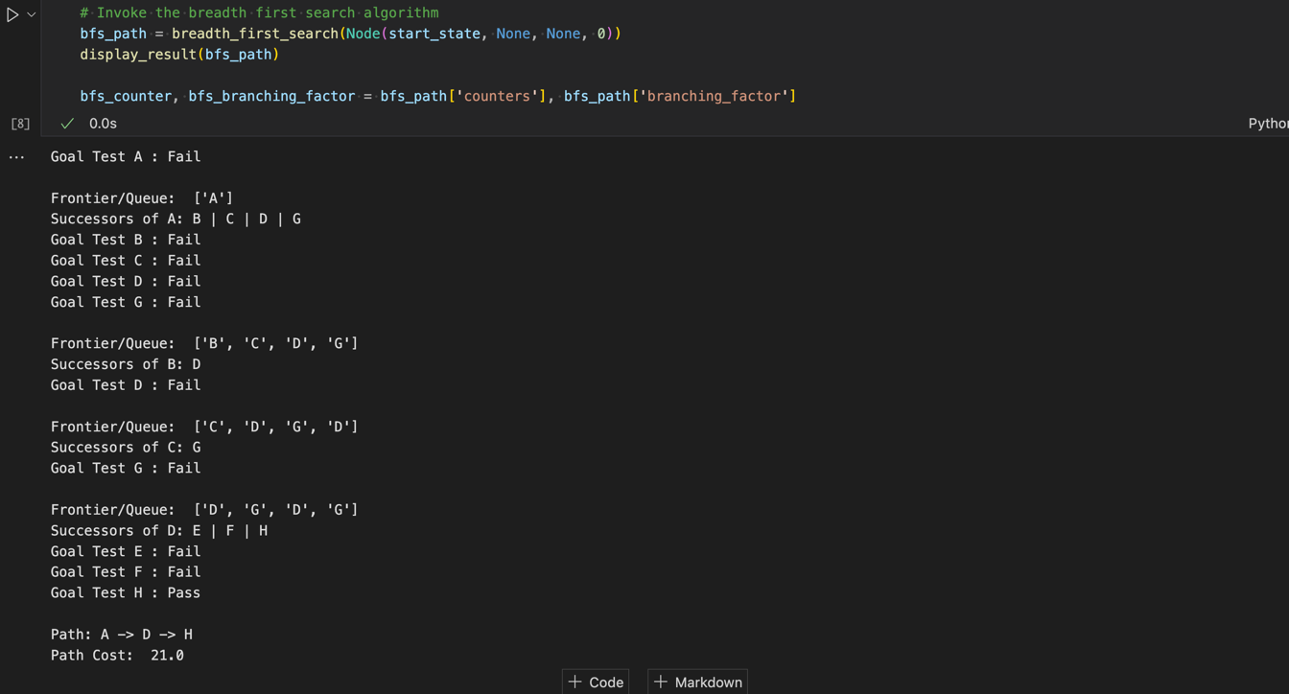

- RBFS Result:
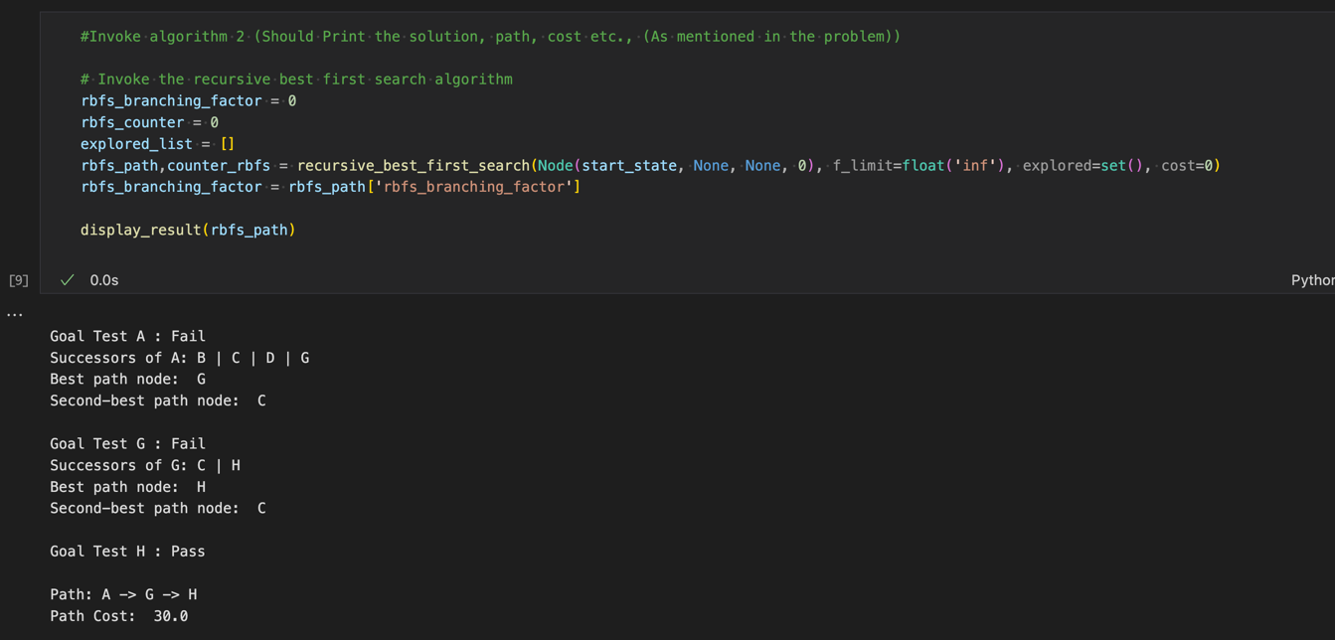

- Time and Space complexities results:
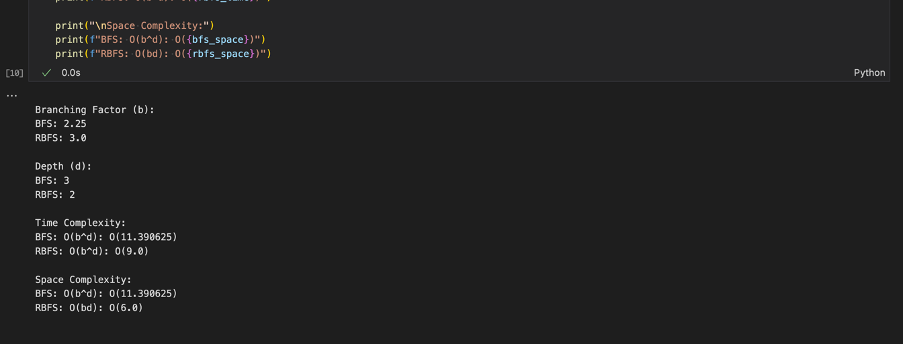

Other details:

- PDF attached includes the BFS & RBFS algorithm’s detailed:
  - Description
  - Implementation details
  - Time & Space complexities details
- Python notebook attached has the outputs included.

